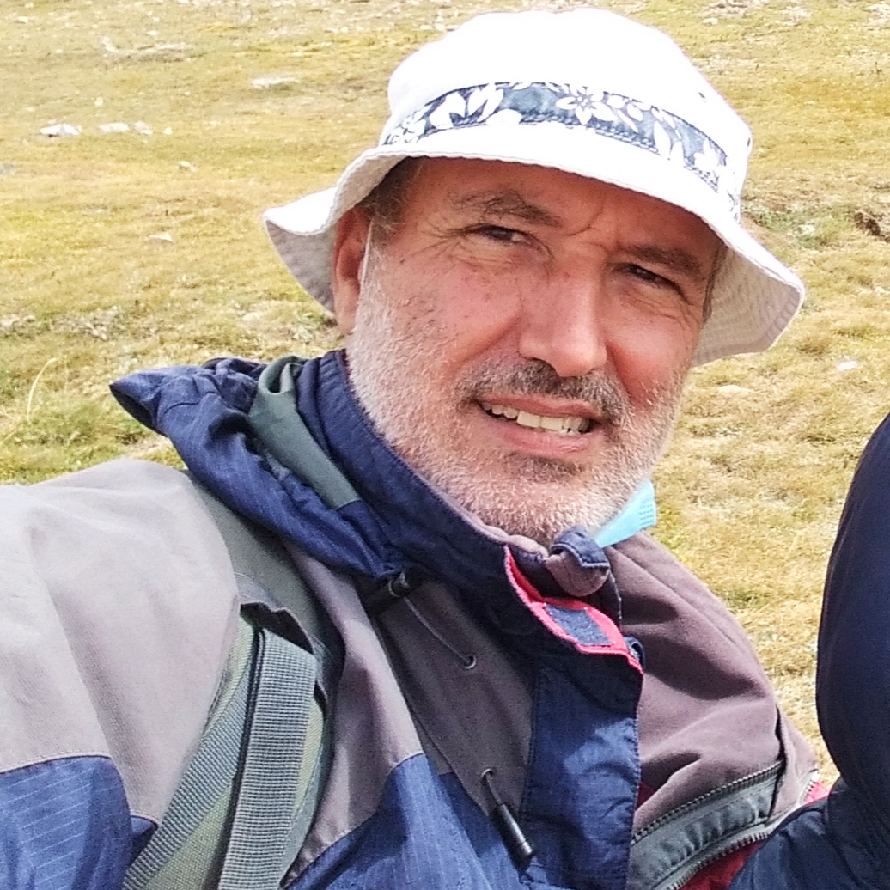
THIS with Mr. Forest!!!

Helping Some Forest Inhabitants a bit during Winter
Activity: | Building a natural bird feeding station.
Aim: | We wish for students to recognize that some living organisms inhabiting the forest (next to our school) have a hard time securing food during winter because it is a time of very low productivity. In short, we want them to know that there are cycles of productivity in the forest and everyone living in it will get affected.
Objective: | •Students will learn how to construct a natural bird feeding station  • Students will practice their English vocabulary and oral competence  • Students will understand the cyclic nature of forests (how food is produced and used in the forest)
Materials | 1 apple, 1 string (50 cm.), 2 sticks, Sunflower seeds (see diagram below)
Activity. | - Students are greeted and asked if they know how food is produced and consumed in the forest during the winter season. (Instructors helps talking about trees. Then ask about birds).  - Instructor shares the concept of helping (pros and cons) forest animals (wild versus near-urban sites).  - Instructors demonstrates how to construct a bird feeding station using the materials.  - Two groups of students construct two stations and place it at nearby trees.  - Instructor asks students to discuss a bit the location and ask them if they are going to be able to monitor the feeding.
