**Find Your Treasure!!!**



**Start Here**

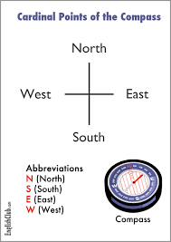

Escola Montseny

1. **At the starting point face North-East and point your compass to the green post in front of you.**
2. **Adjust your compass to 80 degrees NE and take 100 steps approximately until you reach the green post.**
3. **At the green post adjust your compass to 10 degrees NE and follow through the forest until you emerge to a dirt road (about 30 steps).**
4. **Adjust your compass to 295 degrees NW and take about 57 steps until you reach a palm tree stump. You will be at the beginning of a trail.**
5. **Adjust compass at 40 degrees NE and take 30 steps. To your right you will see a trail that goes uphill through some cypress trees.**
6. **Adjust your compass to 90 degrees NE and follow the trail until you reach a dirt road.**
7. **Once you reach the dirt road, look to your right for a metal post painted red and white. Go to it.**
8. **Once at the post, adjust your compass to 330 degrees NW and take about 22 steps. Your treasure will be there !!!!**